Table of Contents

1. Mini Project 1: Simple ML Model Deployment 2

2. Git hub link of stroke detection project: 2

3. Console output of building a package 2

4. FastApi Application 5

5. CI workflow 6

6. Dockerization 6

7. Docker images 7

8. Docker image In VS code 7

9. Running Docker app from CLI 7

10. Stop app and push to image to docker 7

11. Added Docker pass_token and secret 8

12. Full CI pipeline is running successfully 8

13. Cloud-9 setup 8

14. Git clone in AWS environment 8

15. Train and Predict running in AWS 9

16. Creating & Launching EC2 9

17. Docker Installation 9

18. Adding self-hosted runner in Git hub Repo: 11

19. Running GitHub Actions: 11

20. CD workflow 12

21. Running FastApi app on EC2 instance 12

# Mini Project 1: Simple ML Model Deployment

**Objective:** Deploy a simple ML model using a pre-trained model and serve predictions through an API endpoint.

1. Create a Git repository for the project and include the ML model code and API server code.
2. Implement the API server using a Python web framework like Flask or FastAPI.
3. Set up a GitHub Actions workflow to automate model testing and deployment on each push to the repository.
4. Build a Docker container for the API server with the necessary dependencies and the pre-trained model.
5. Use Docker Hub to store the Docker image.
6. Deploy the Docker container on AWS EC2.
7. Set up an API Gateway to expose the API endpoint securely.

# Git hub link of stroke detection project:

<https://github.com/pycsr/stroke_detection>

# Console output of building a package

(venv) (base) quicktech@psoni stroke_detection % python -m build

* Creating venv isolated environment...

* Installing packages in isolated environment... (setuptools>=42, wheel)

* Getting build dependencies for sdist...

/Users/quicktech/Documents/IISc_AIMLOps_Projects/Part-B_MiniProject/stroke_detection

running egg_info

creating stroke_detection_model.egg-info

writing stroke_detection_model.egg-info/PKG-INFO

writing dependency_links to stroke_detection_model.egg-info/dependency_links.txt

writing requirements to stroke_detection_model.egg-info/requires.txt

writing top-level names to stroke_detection_model.egg-info/top_level.txt

writing manifest file 'stroke_detection_model.egg-info/SOURCES.txt'

reading manifest file 'stroke_detection_model.egg-info/SOURCES.txt'

reading manifest template 'MANIFEST.in'

warning: no files found matching '*.txt'

warning: no files found matching '*.pkl'

warning: no previously-included files found matching '*.log'

warning: no previously-included files found matching '*.cfg'

warning: no previously-included files matching '__pycache__' found under directory '*'

adding license file 'LICENSE'

writing manifest file 'stroke_detection_model.egg-info/SOURCES.txt'

* Building sdist...

/Users/quicktech/Documents/IISc_AIMLOps_Projects/Part-B_MiniProject/stroke_detection

running sdist

running egg_info

writing stroke_detection_model.egg-info/PKG-INFO

writing dependency_links to stroke_detection_model.egg-info/dependency_links.txt

writing requirements to stroke_detection_model.egg-info/requires.txt

writing top-level names to stroke_detection_model.egg-info/top_level.txt

reading manifest file 'stroke_detection_model.egg-info/SOURCES.txt'

reading manifest template 'MANIFEST.in'

warning: no files found matching '*.txt'

warning: no files found matching '*.pkl'

warning: no previously-included files found matching '*.log'

warning: no previously-included files found matching '*.cfg'

warning: no previously-included files matching '__pycache__' found under directory '*'

adding license file 'LICENSE'

writing manifest file 'stroke_detection_model.egg-info/SOURCES.txt'

running check

creating stroke_detection_model-0.0.1

creating stroke_detection_model-0.0.1/requirements

creating stroke_detection_model-0.0.1/stroke_detection_model

creating stroke_detection_model-0.0.1/stroke_detection_model/config

creating stroke_detection_model-0.0.1/stroke_detection_model/datasets

creating stroke_detection_model-0.0.1/stroke_detection_model/processing

creating stroke_detection_model-0.0.1/stroke_detection_model/trained_models

creating stroke_detection_model-0.0.1/stroke_detection_model.egg-info

creating stroke_detection_model-0.0.1/tests

copying files to stroke_detection_model-0.0.1...

copying LICENSE -> stroke_detection_model-0.0.1

copying MANIFEST.in -> stroke_detection_model-0.0.1

copying README.md -> stroke_detection_model-0.0.1

copying pyproject.toml -> stroke_detection_model-0.0.1

copying setup.py -> stroke_detection_model-0.0.1

copying ./requirements/requirements.txt -> stroke_detection_model-0.0.1/./requirements

copying ./requirements/test_requirements.txt -> stroke_detection_model-0.0.1/./requirements

copying ./stroke_detection_model/.DS_Store -> stroke_detection_model-0.0.1/./stroke_detection_model

copying ./stroke_detection_model/VERSION -> stroke_detection_model-0.0.1/./stroke_detection_model

copying ./stroke_detection_model/__init__.py -> stroke_detection_model-0.0.1/./stroke_detection_model

copying ./stroke_detection_model/config.yml -> stroke_detection_model-0.0.1/./stroke_detection_model

copying ./stroke_detection_model/pipeline.py -> stroke_detection_model-0.0.1/./stroke_detection_model

copying ./stroke_detection_model/predict.py -> stroke_detection_model-0.0.1/./stroke_detection_model

copying ./stroke_detection_model/train_pipeline.py -> stroke_detection_model-0.0.1/./stroke_detection_model

copying ./stroke_detection_model/config/__init__.py -> stroke_detection_model-0.0.1/./stroke_detection_model/config

copying ./stroke_detection_model/config/core.py -> stroke_detection_model-0.0.1/./stroke_detection_model/config

copying ./stroke_detection_model/datasets/.DS_Store -> stroke_detection_model-0.0.1/./stroke_detection_model/datasets

copying ./stroke_detection_model/datasets/__init__.py -> stroke_detection_model-0.0.1/./stroke_detection_model/datasets

copying ./stroke_detection_model/datasets/healthcare-dataset-stroke-data.csv -> stroke_detection_model-0.0.1/./stroke_detection_model/datasets

copying ./stroke_detection_model/processing/__init__.py -> stroke_detection_model-0.0.1/./stroke_detection_model/processing

copying ./stroke_detection_model/processing/data_manager.py -> stroke_detection_model-0.0.1/./stroke_detection_model/processing

copying ./stroke_detection_model/processing/features.py -> stroke_detection_model-0.0.1/./stroke_detection_model/processing

copying ./stroke_detection_model/processing/validation.py -> stroke_detection_model-0.0.1/./stroke_detection_model/processing

copying ./stroke_detection_model/trained_models/__init__.py -> stroke_detection_model-0.0.1/./stroke_detection_model/trained_models

copying ./stroke_detection_model/trained_models/stroke_detection_model_output_v0.0.1.pkl -> stroke_detection_model-0.0.1/./stroke_detection_model/trained_models

copying stroke_detection_model/VERSION -> stroke_detection_model-0.0.1/stroke_detection_model

copying stroke_detection_model/__init__.py -> stroke_detection_model-0.0.1/stroke_detection_model

copying stroke_detection_model/config.yml -> stroke_detection_model-0.0.1/stroke_detection_model

copying stroke_detection_model/pipeline.py -> stroke_detection_model-0.0.1/stroke_detection_model

copying stroke_detection_model/predict.py -> stroke_detection_model-0.0.1/stroke_detection_model

copying stroke_detection_model/train_pipeline.py -> stroke_detection_model-0.0.1/stroke_detection_model

copying stroke_detection_model.egg-info/PKG-INFO -> stroke_detection_model-0.0.1/stroke_detection_model.egg-info

copying stroke_detection_model.egg-info/SOURCES.txt -> stroke_detection_model-0.0.1/stroke_detection_model.egg-info

copying stroke_detection_model.egg-info/dependency_links.txt -> stroke_detection_model-0.0.1/stroke_detection_model.egg-info

copying stroke_detection_model.egg-info/requires.txt -> stroke_detection_model-0.0.1/stroke_detection_model.egg-info

copying stroke_detection_model.egg-info/top_level.txt -> stroke_detection_model-0.0.1/stroke_detection_model.egg-info

copying stroke_detection_model/config/__init__.py -> stroke_detection_model-0.0.1/stroke_detection_model/config

copying stroke_detection_model/config/core.py -> stroke_detection_model-0.0.1/stroke_detection_model/config

copying stroke_detection_model/datasets/__init__.py -> stroke_detection_model-0.0.1/stroke_detection_model/datasets

copying stroke_detection_model/datasets/healthcare-dataset-stroke-data.csv -> stroke_detection_model-0.0.1/stroke_detection_model/datasets

copying stroke_detection_model/processing/__init__.py -> stroke_detection_model-0.0.1/stroke_detection_model/processing

copying stroke_detection_model/processing/data_manager.py -> stroke_detection_model-0.0.1/stroke_detection_model/processing

copying stroke_detection_model/processing/features.py -> stroke_detection_model-0.0.1/stroke_detection_model/processing

copying stroke_detection_model/processing/validation.py -> stroke_detection_model-0.0.1/stroke_detection_model/processing

copying stroke_detection_model/trained_models/__init__.py -> stroke_detection_model-0.0.1/stroke_detection_model/trained_models

copying stroke_detection_model/trained_models/stroke_detection_model_output_v0.0.1.pkl -> stroke_detection_model-0.0.1/stroke_detection_model/trained_models

copying tests/test_features.py -> stroke_detection_model-0.0.1/tests

copying tests/test_predictions.py -> stroke_detection_model-0.0.1/tests

copying stroke_detection_model.egg-info/SOURCES.txt -> stroke_detection_model-0.0.1/stroke_detection_model.egg-info

Writing stroke_detection_model-0.0.1/setup.cfg

Creating tar archive

removing 'stroke_detection_model-0.0.1' (and everything under it)

* Building wheel from sdist

* Creating venv isolated environment...

* Installing packages in isolated environment... (setuptools>=42, wheel)

* Getting build dependencies for wheel...

/private/var/folders/vs/6l92ypwj3sbc973853q9w9w00000gn/T/build-via-sdist-ca8j0naj/stroke_detection_model-0.0.1

running egg_info

writing stroke_detection_model.egg-info/PKG-INFO

writing dependency_links to stroke_detection_model.egg-info/dependency_links.txt

writing requirements to stroke_detection_model.egg-info/requires.txt

writing top-level names to stroke_detection_model.egg-info/top_level.txt

reading manifest file 'stroke_detection_model.egg-info/SOURCES.txt'

reading manifest template 'MANIFEST.in'

warning: no files found matching '*.txt'

warning: no files found matching '*.pkl'

warning: no previously-included files found matching '*.log'

warning: no previously-included files matching '__pycache__' found under directory '*'

warning: no previously-included files matching '*.py[co]' found under directory '*'

adding license file 'LICENSE'

writing manifest file 'stroke_detection_model.egg-info/SOURCES.txt'

* Installing packages in isolated environment... (wheel)

* Building wheel...

/private/var/folders/vs/6l92ypwj3sbc973853q9w9w00000gn/T/build-via-sdist-ca8j0naj/stroke_detection_model-0.0.1

running bdist_wheel

running build

running build_py

creating build

creating build/lib

creating build/lib/stroke_detection_model

copying stroke_detection_model/train_pipeline.py -> build/lib/stroke_detection_model

copying stroke_detection_model/predict.py -> build/lib/stroke_detection_model

copying stroke_detection_model/__init__.py -> build/lib/stroke_detection_model

copying stroke_detection_model/pipeline.py -> build/lib/stroke_detection_model

creating build/lib/stroke_detection_model/config

copying stroke_detection_model/config/__init__.py -> build/lib/stroke_detection_model/config

copying stroke_detection_model/config/core.py -> build/lib/stroke_detection_model/config

creating build/lib/stroke_detection_model/processing

copying stroke_detection_model/processing/__init__.py -> build/lib/stroke_detection_model/processing

copying stroke_detection_model/processing/features.py -> build/lib/stroke_detection_model/processing

copying stroke_detection_model/processing/data_manager.py -> build/lib/stroke_detection_model/processing

copying stroke_detection_model/processing/validation.py -> build/lib/stroke_detection_model/processing

creating build/lib/stroke_detection_model/datasets

copying stroke_detection_model/datasets/__init__.py -> build/lib/stroke_detection_model/datasets

creating build/lib/stroke_detection_model/trained_models

copying stroke_detection_model/trained_models/__init__.py -> build/lib/stroke_detection_model/trained_models

running egg_info

writing stroke_detection_model.egg-info/PKG-INFO

writing dependency_links to stroke_detection_model.egg-info/dependency_links.txt

writing requirements to stroke_detection_model.egg-info/requires.txt

writing top-level names to stroke_detection_model.egg-info/top_level.txt

reading manifest file 'stroke_detection_model.egg-info/SOURCES.txt'

reading manifest template 'MANIFEST.in'

warning: no files found matching '*.txt'

warning: no files found matching '*.pkl'

warning: no previously-included files found matching '*.log'

warning: no previously-included files matching '__pycache__' found under directory '*'

warning: no previously-included files matching '*.py[co]' found under directory '*'

adding license file 'LICENSE'

writing manifest file 'stroke_detection_model.egg-info/SOURCES.txt'

copying stroke_detection_model/VERSION -> build/lib/stroke_detection_model

copying stroke_detection_model/config.yml -> build/lib/stroke_detection_model

copying stroke_detection_model/datasets/healthcare-dataset-stroke-data.csv -> build/lib/stroke_detection_model/datasets

copying stroke_detection_model/trained_models/stroke_detection_model_output_v0.0.1.pkl -> build/lib/stroke_detection_model/trained_models

installing to build/bdist.macosx-10.9-x86_64/wheel

running install

running install_lib

creating build/bdist.macosx-10.9-x86_64

creating build/bdist.macosx-10.9-x86_64/wheel

creating build/bdist.macosx-10.9-x86_64/wheel/stroke_detection_model

copying build/lib/stroke_detection_model/train_pipeline.py -> build/bdist.macosx-10.9-x86_64/wheel/stroke_detection_model

creating build/bdist.macosx-10.9-x86_64/wheel/stroke_detection_model/config

copying build/lib/stroke_detection_model/config/__init__.py -> build/bdist.macosx-10.9-x86_64/wheel/stroke_detection_model/config

copying build/lib/stroke_detection_model/config/core.py -> build/bdist.macosx-10.9-x86_64/wheel/stroke_detection_model/config

creating build/bdist.macosx-10.9-x86_64/wheel/stroke_detection_model/processing

copying build/lib/stroke_detection_model/processing/__init__.py -> build/bdist.macosx-10.9-x86_64/wheel/stroke_detection_model/processing

copying build/lib/stroke_detection_model/processing/features.py -> build/bdist.macosx-10.9-x86_64/wheel/stroke_detection_model/processing

copying build/lib/stroke_detection_model/processing/data_manager.py -> build/bdist.macosx-10.9-x86_64/wheel/stroke_detection_model/processing

copying build/lib/stroke_detection_model/processing/validation.py -> build/bdist.macosx-10.9-x86_64/wheel/stroke_detection_model/processing

creating build/bdist.macosx-10.9-x86_64/wheel/stroke_detection_model/datasets

copying build/lib/stroke_detection_model/datasets/__init__.py -> build/bdist.macosx-10.9-x86_64/wheel/stroke_detection_model/datasets

copying build/lib/stroke_detection_model/datasets/healthcare-dataset-stroke-data.csv -> build/bdist.macosx-10.9-x86_64/wheel/stroke_detection_model/datasets

copying build/lib/stroke_detection_model/predict.py -> build/bdist.macosx-10.9-x86_64/wheel/stroke_detection_model

copying build/lib/stroke_detection_model/__init__.py -> build/bdist.macosx-10.9-x86_64/wheel/stroke_detection_model

creating build/bdist.macosx-10.9-x86_64/wheel/stroke_detection_model/trained_models

copying build/lib/stroke_detection_model/trained_models/stroke_detection_model_output_v0.0.1.pkl -> build/bdist.macosx-10.9-x86_64/wheel/stroke_detection_model/trained_models

copying build/lib/stroke_detection_model/trained_models/__init__.py -> build/bdist.macosx-10.9-x86_64/wheel/stroke_detection_model/trained_models

copying build/lib/stroke_detection_model/VERSION -> build/bdist.macosx-10.9-x86_64/wheel/stroke_detection_model

copying build/lib/stroke_detection_model/pipeline.py -> build/bdist.macosx-10.9-x86_64/wheel/stroke_detection_model

copying build/lib/stroke_detection_model/config.yml -> build/bdist.macosx-10.9-x86_64/wheel/stroke_detection_model

running install_egg_info

Copying stroke_detection_model.egg-info to build/bdist.macosx-10.9-x86_64/wheel/stroke_detection_model-0.0.1-py3.11.egg-info

running install_scripts

creating build/bdist.macosx-10.9-x86_64/wheel/stroke_detection_model-0.0.1.dist-info/WHEEL

creating '/Users/quicktech/Documents/IISc_AIMLOps_Projects/Part-B_MiniProject/stroke_detection/dist/.tmp-e7ycyhc8/stroke_detection_model-0.0.1-py3-none-any.whl' and adding 'build/bdist.macosx-10.9-x86_64/wheel' to it

adding 'stroke_detection_model/VERSION'

adding 'stroke_detection_model/__init__.py'

adding 'stroke_detection_model/config.yml'

adding 'stroke_detection_model/pipeline.py'

adding 'stroke_detection_model/predict.py'

adding 'stroke_detection_model/train_pipeline.py'

adding 'stroke_detection_model/config/__init__.py'

adding 'stroke_detection_model/config/core.py'

adding 'stroke_detection_model/datasets/__init__.py'

adding 'stroke_detection_model/datasets/healthcare-dataset-stroke-data.csv'

adding 'stroke_detection_model/processing/__init__.py'

adding 'stroke_detection_model/processing/data_manager.py'

adding 'stroke_detection_model/processing/features.py'

adding 'stroke_detection_model/processing/validation.py'

adding 'stroke_detection_model/trained_models/__init__.py'

adding 'stroke_detection_model/trained_models/stroke_detection_model_output_v0.0.1.pkl'

adding 'stroke_detection_model-0.0.1.dist-info/LICENSE'

adding 'stroke_detection_model-0.0.1.dist-info/METADATA'

adding 'stroke_detection_model-0.0.1.dist-info/WHEEL'

adding 'stroke_detection_model-0.0.1.dist-info/top_level.txt'

adding 'stroke_detection_model-0.0.1.dist-info/RECORD'

removing build/bdist.macosx-10.9-x86_64/wheel

**Successfully built stroke_detection_model-0.0.1.tar.gz and stroke_detection_model-0.0.1-py3-no**

# FastApi Application

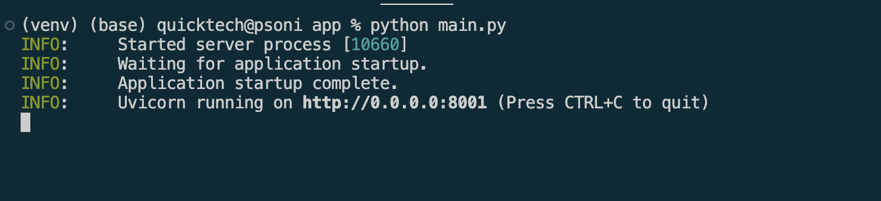

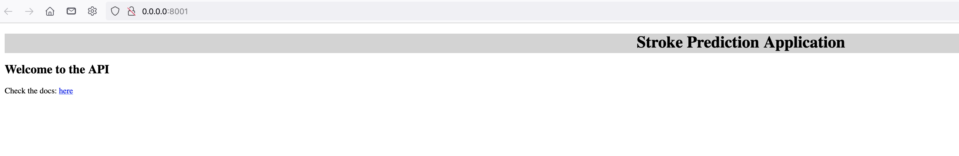

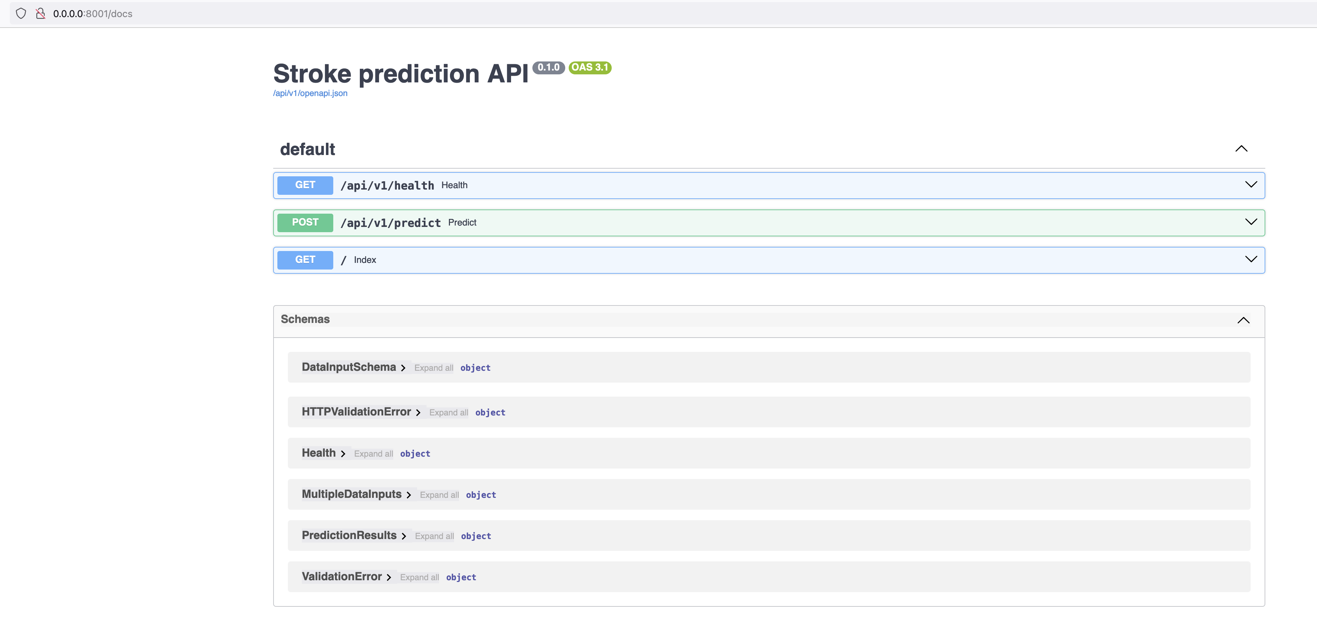

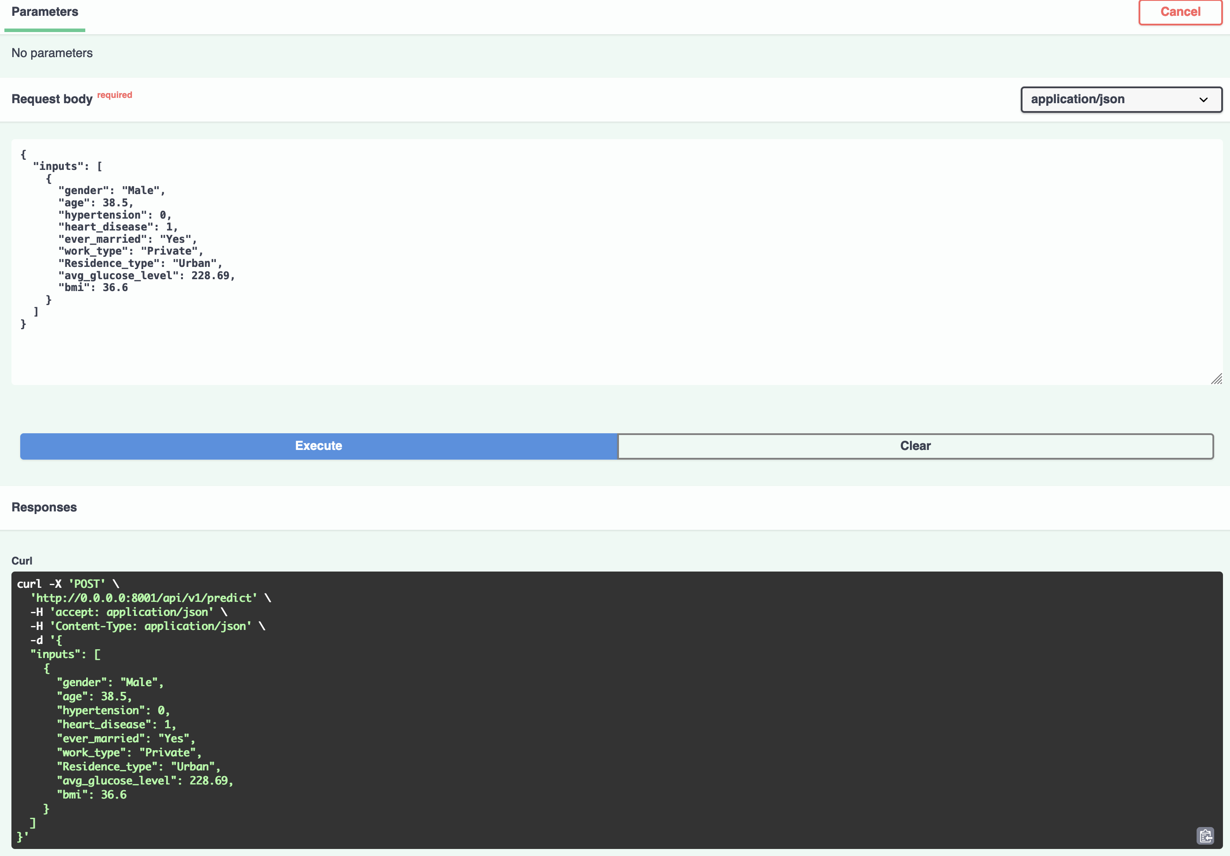

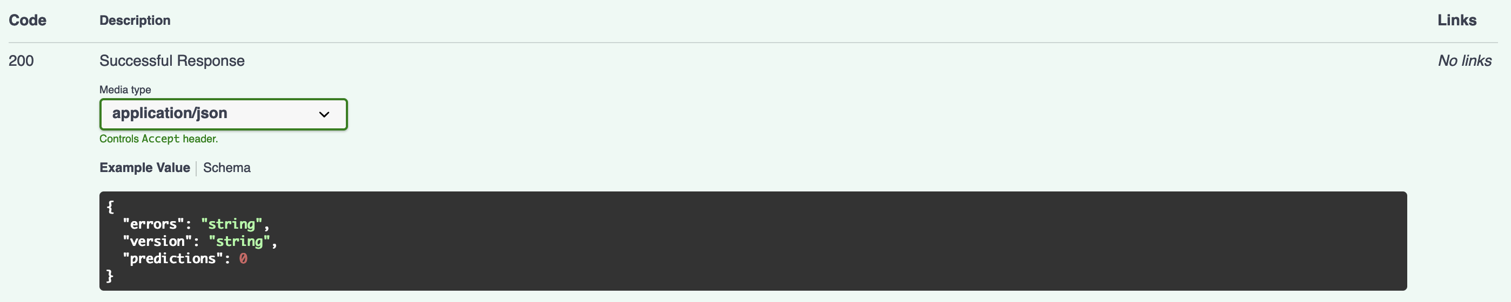

# CI workflow

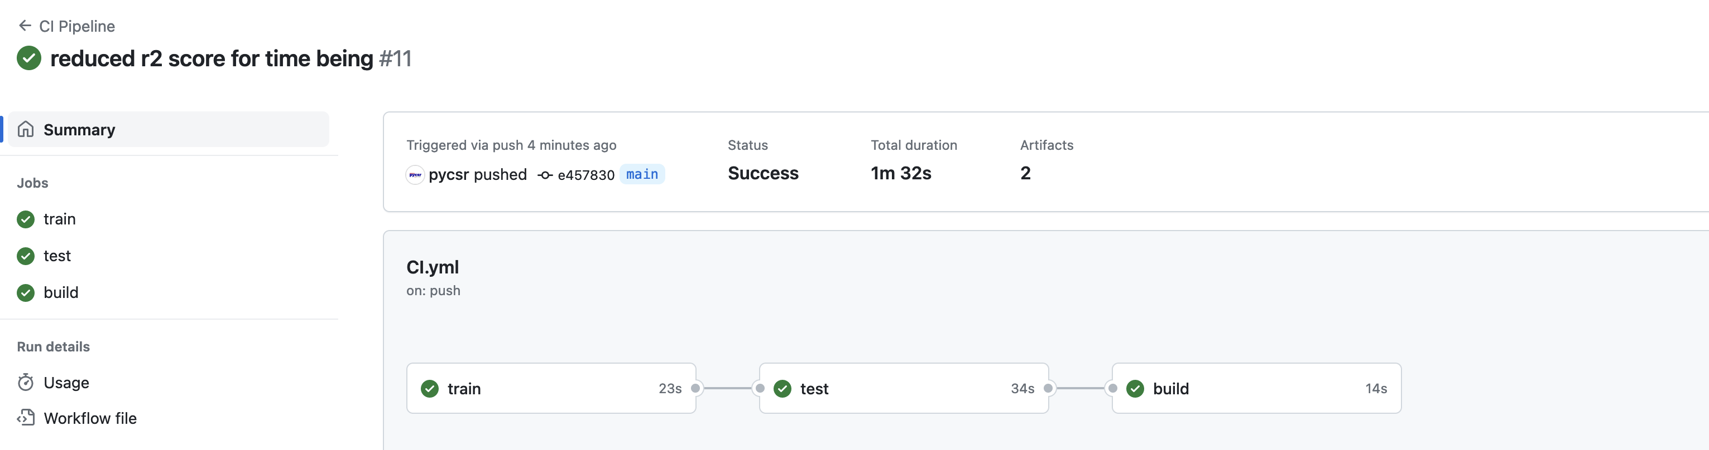

# Dockerization

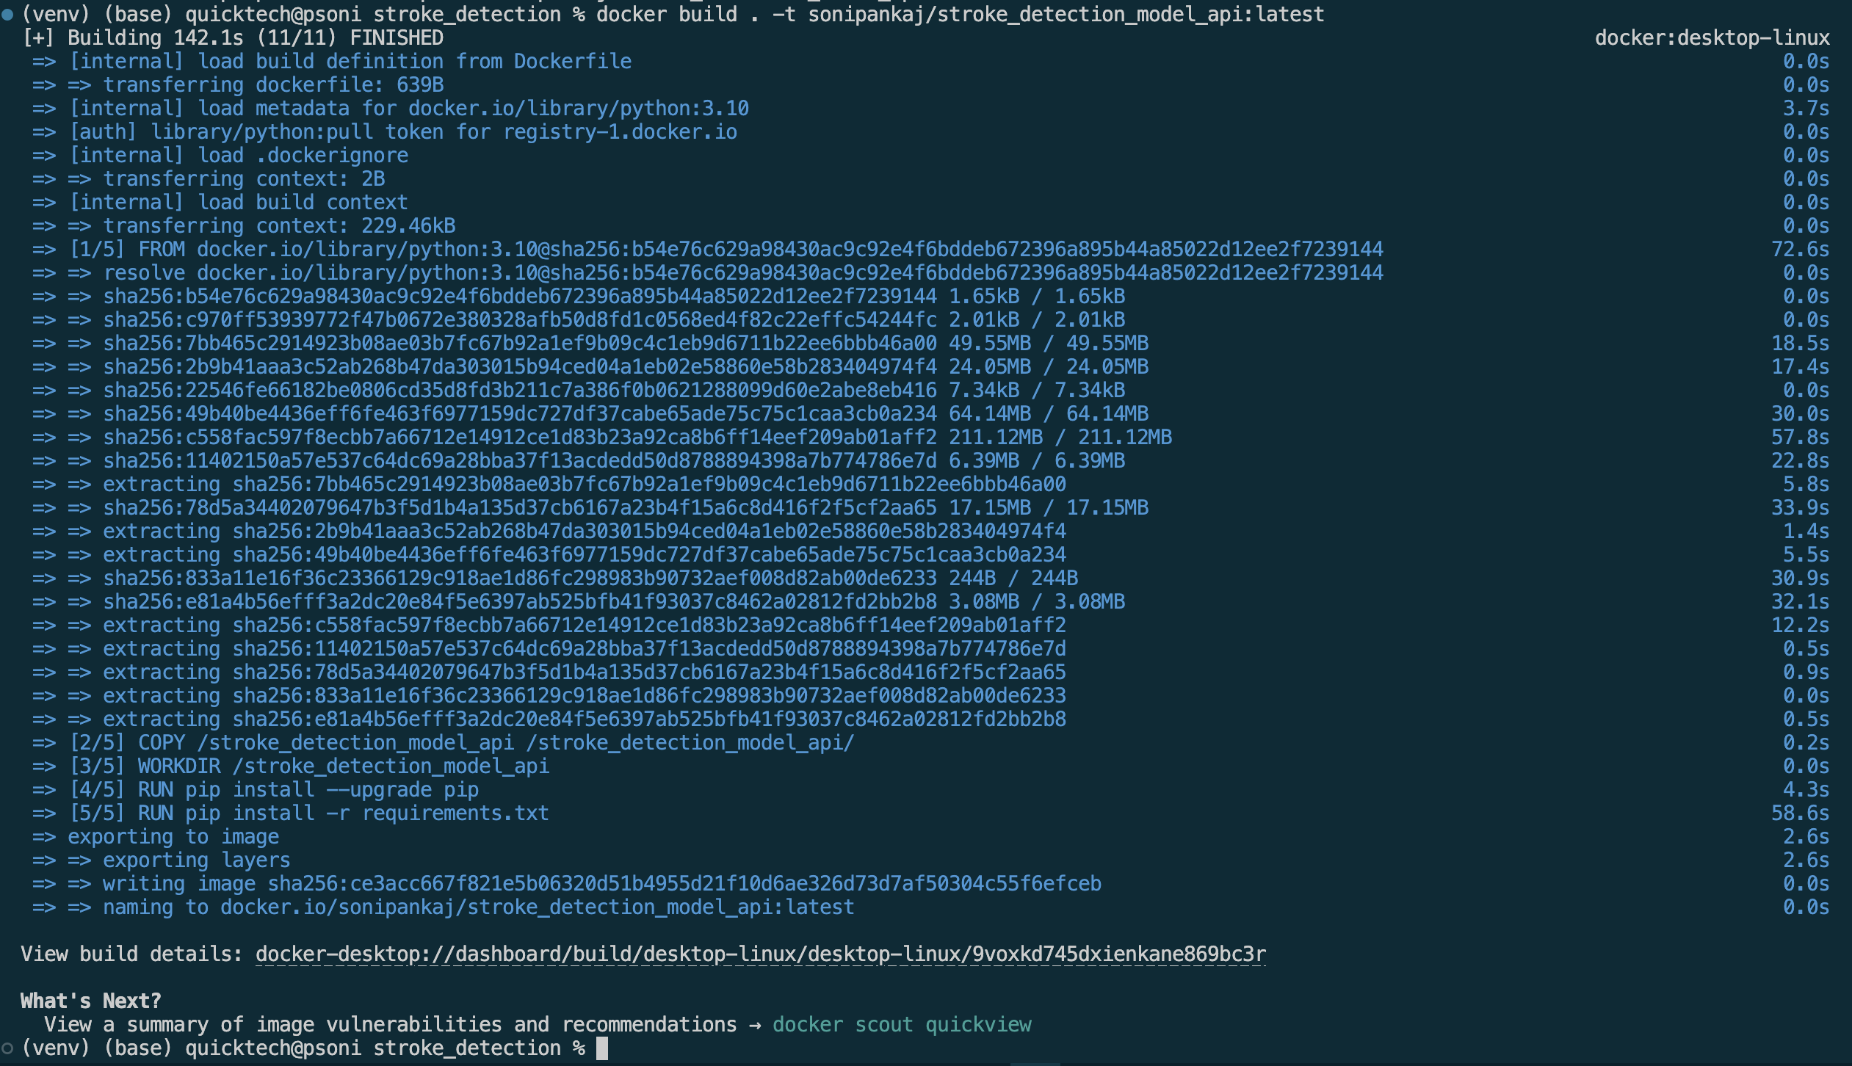

# Docker images

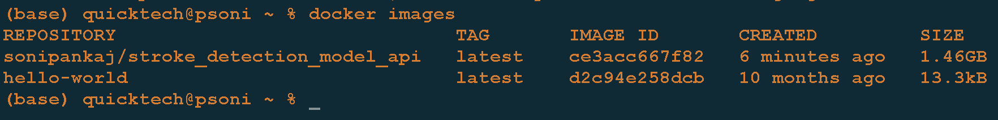

# Docker image In VS code

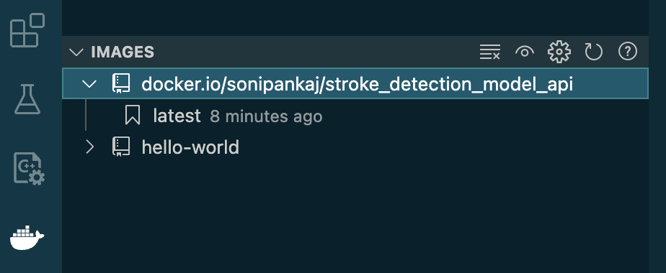

# Running Docker app from CLI

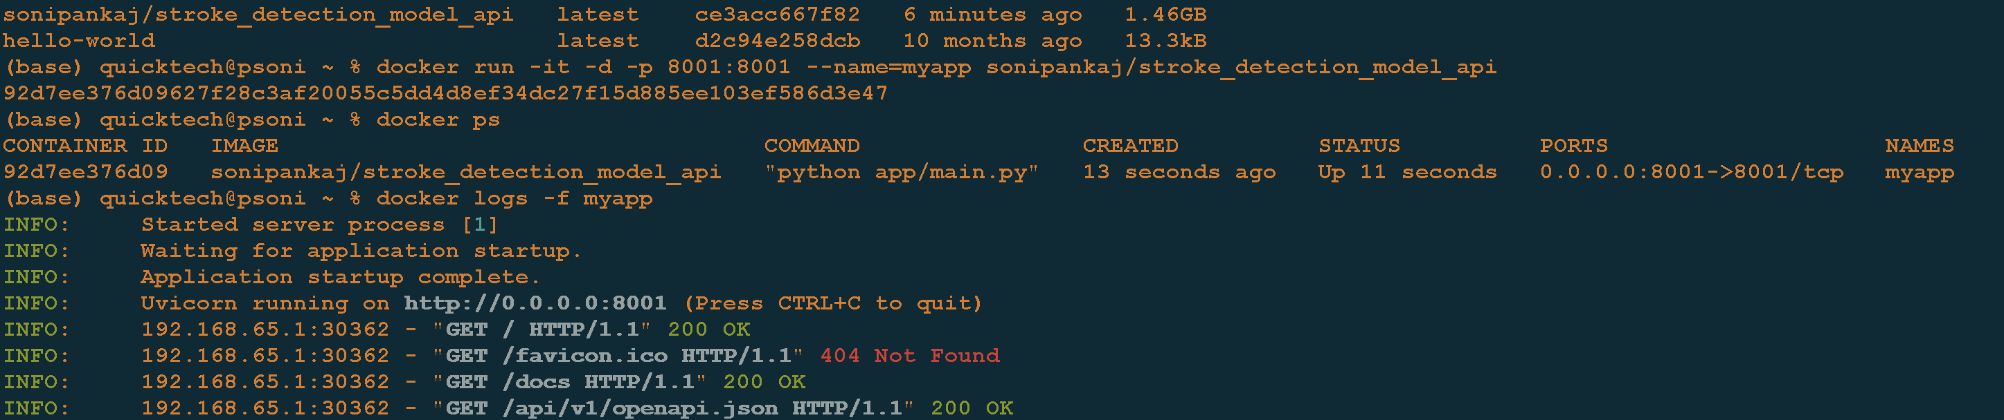

# Stop app and push to image to docker

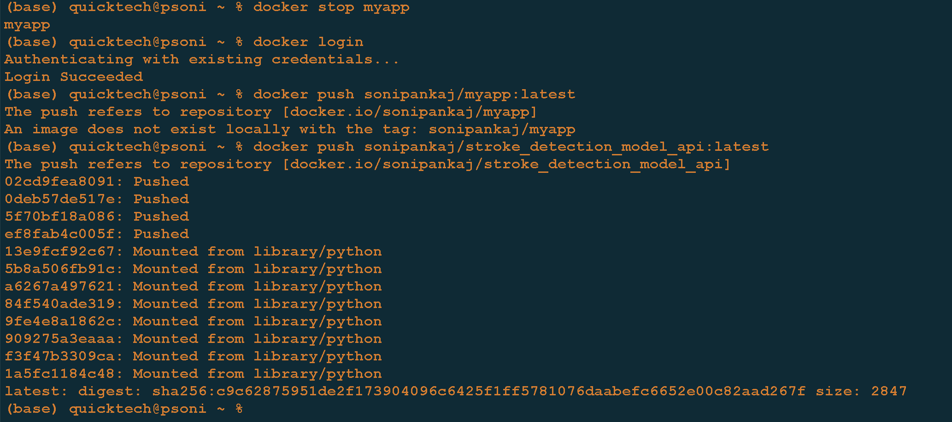

# Added Docker pass_token and secret

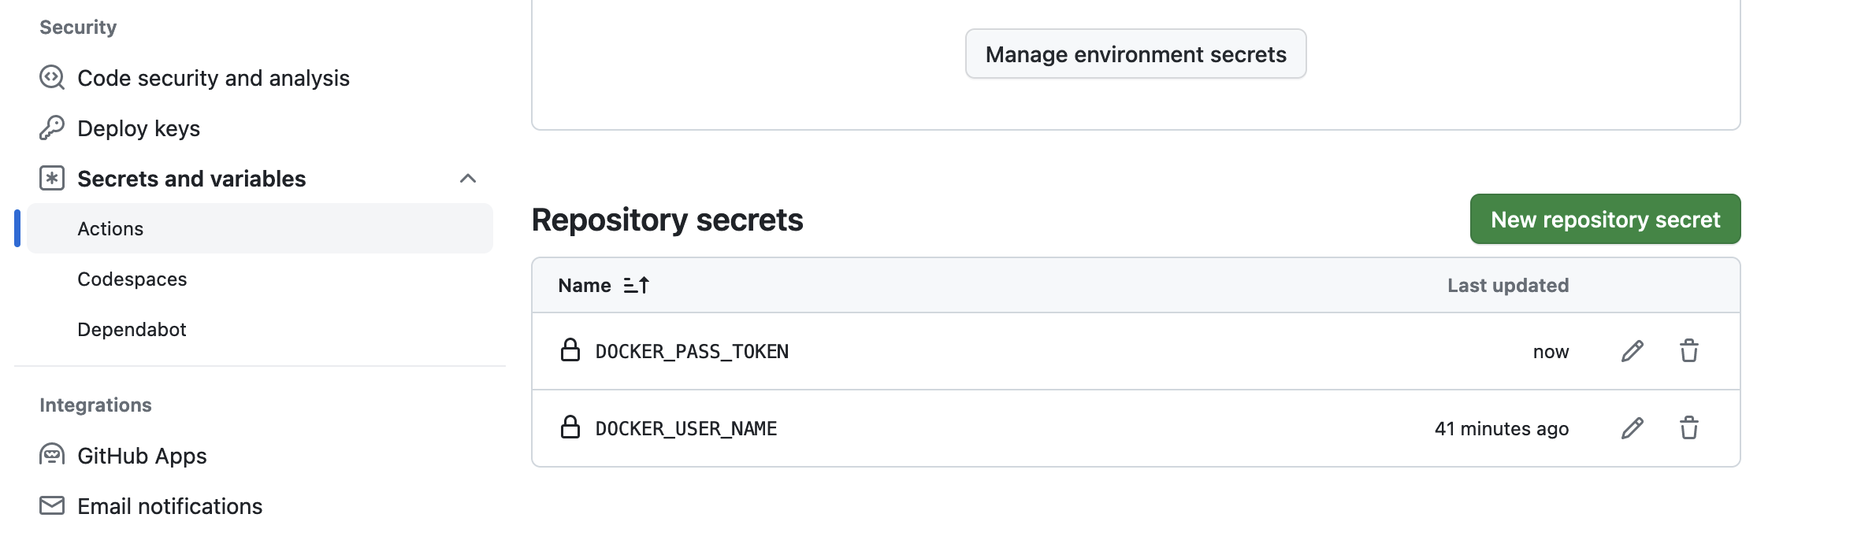

# Full CI pipeline is running successfully

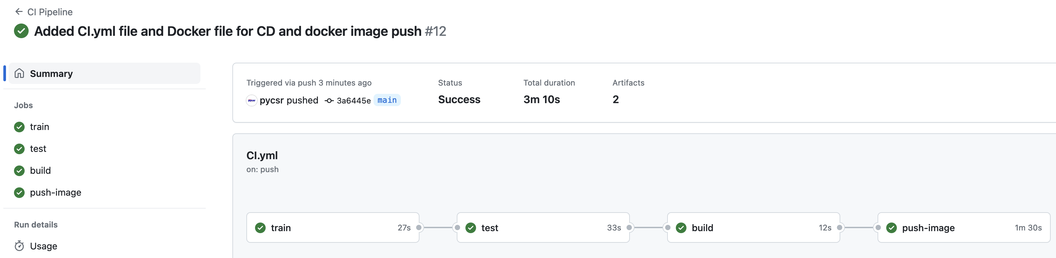

# Cloud-9 setup

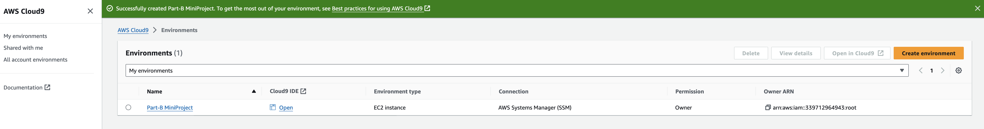

# Git clone in AWS environment

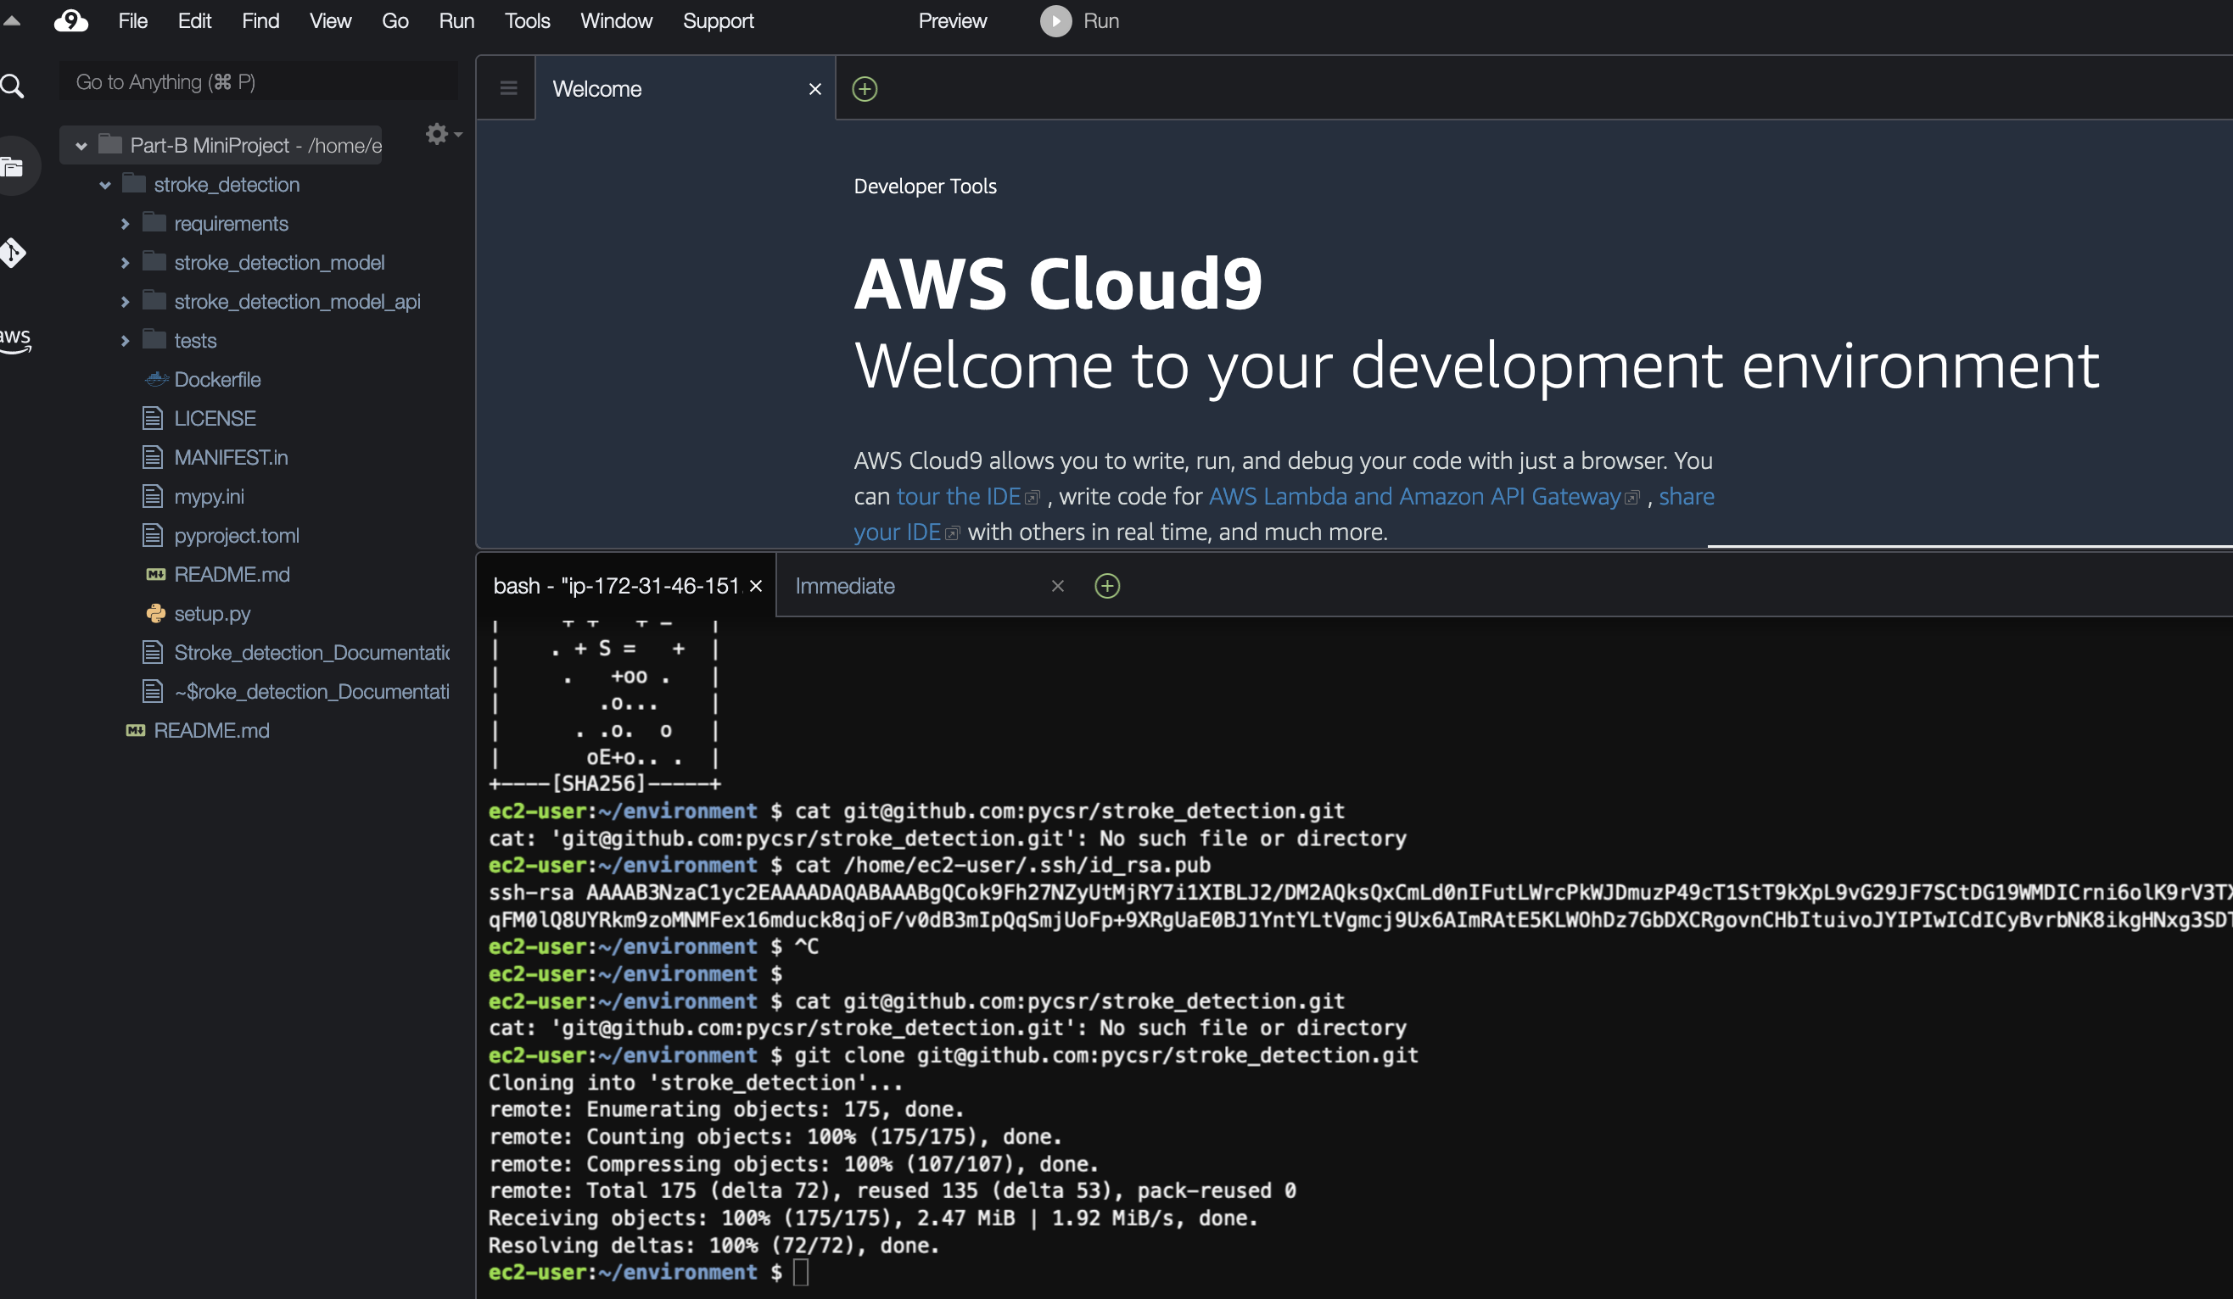

# Train and Predict running in AWS

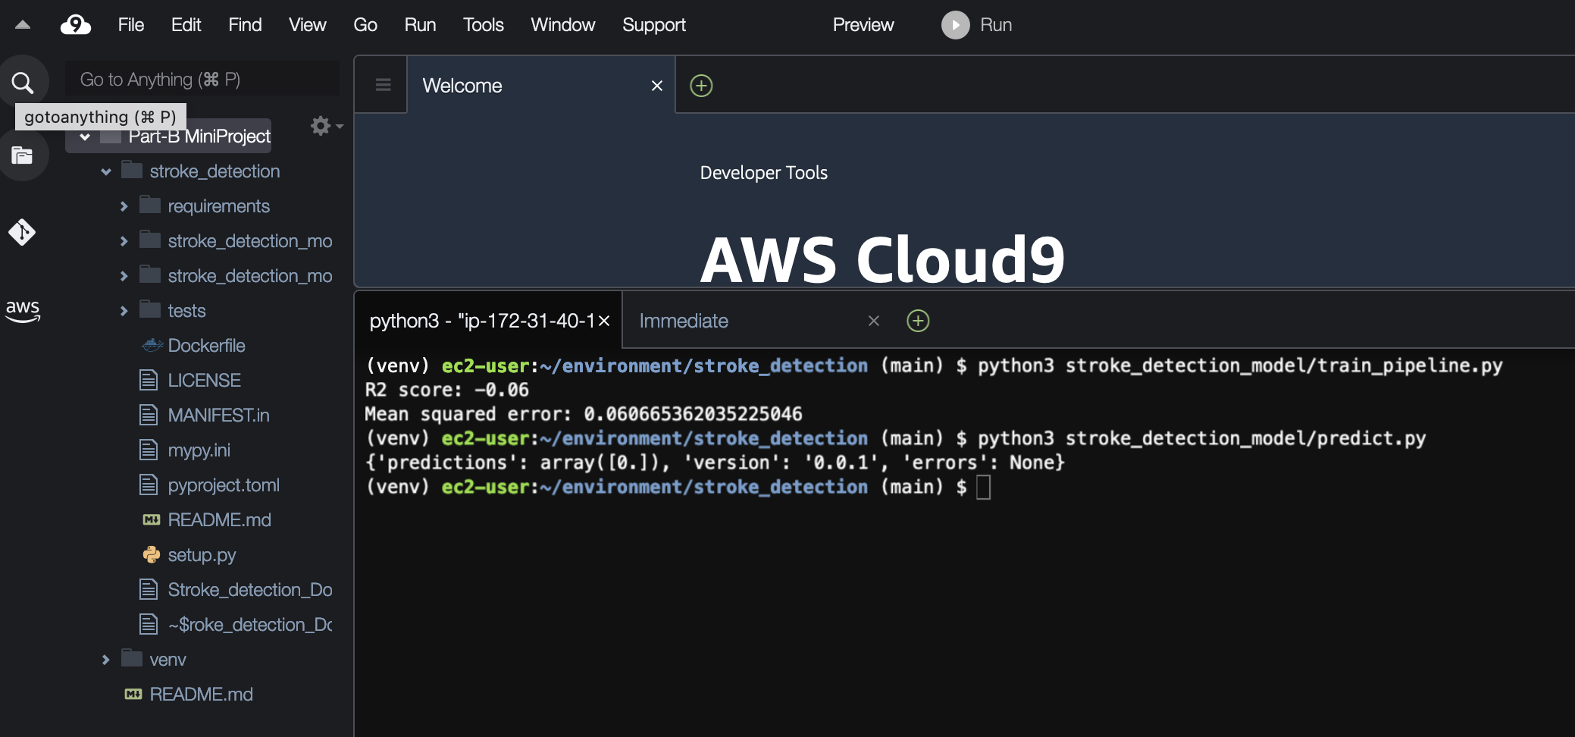

# Creating & Launching EC2

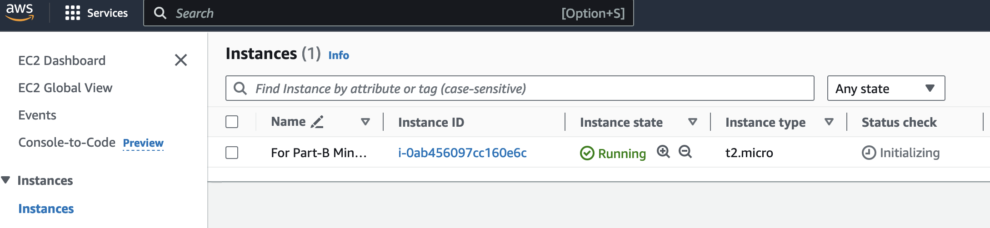

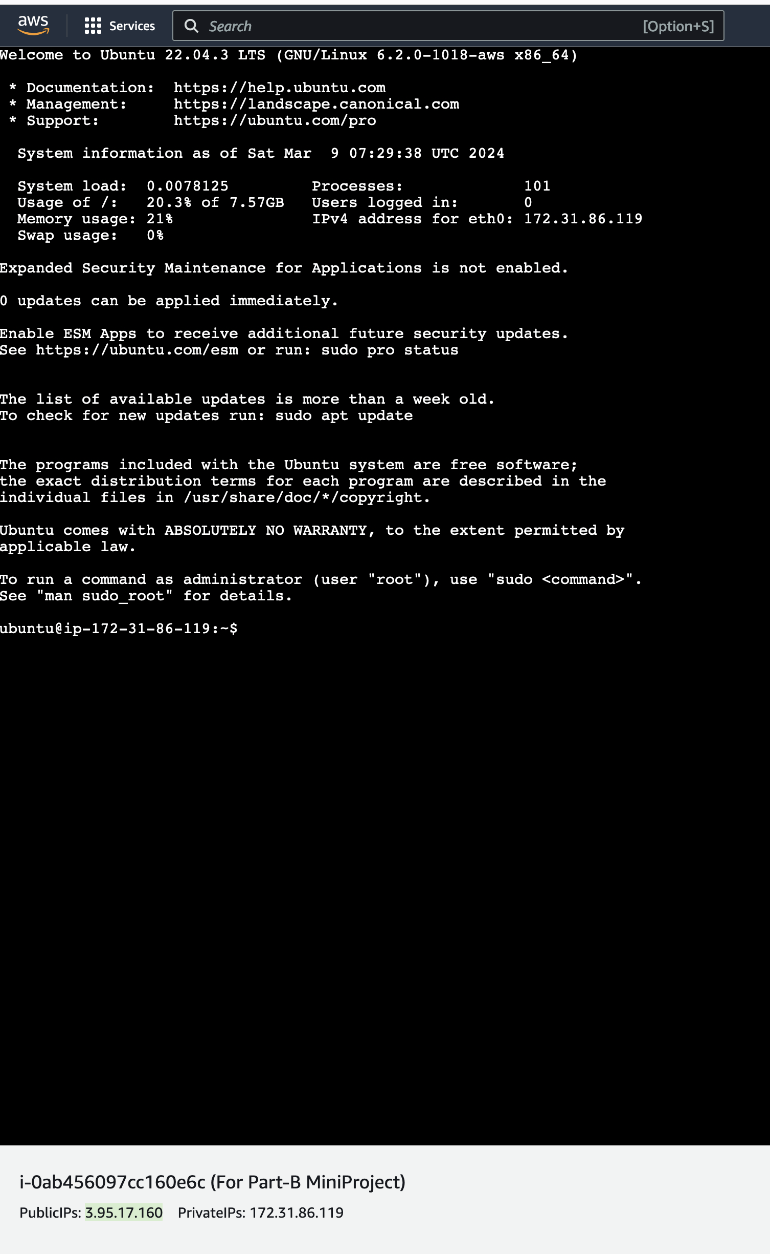

# Docker Installation

**Install Docker on virtual machine / EC2 instance:**

1. Open the terminal.
2. Remove any Docker files that are running in the system, using the following command:

sudo apt-get remove docker docker-engine docker.io

NOTE that we are using the *sudo* keyword along with commands.  
Using *sudo*, users no longer had to change to the root user or log into that account to run administrative commands (such as installing software). Users could run those admin activities through sudo with the same effect as if they were run from the root user account.

1. Get the system up-to-date using the following commands.  
   It will update the package index files on the instance, which contain information about available packages and their versions.

Press enter, if a popup comes saying - Services will be restarted.

1. Install Docker using the following command:

sudo apt install docker.io -y

1. Start docker service and enable the service to start at boot using the following commands:

sudo systemctl start docker

sudo systemctl enable docker

1. Before testing Docker, check the version installed using the following command:

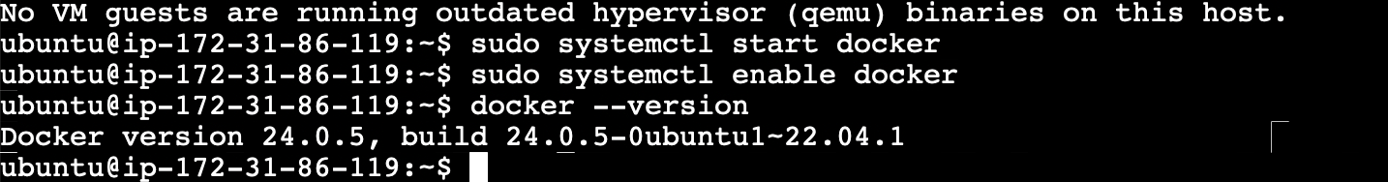

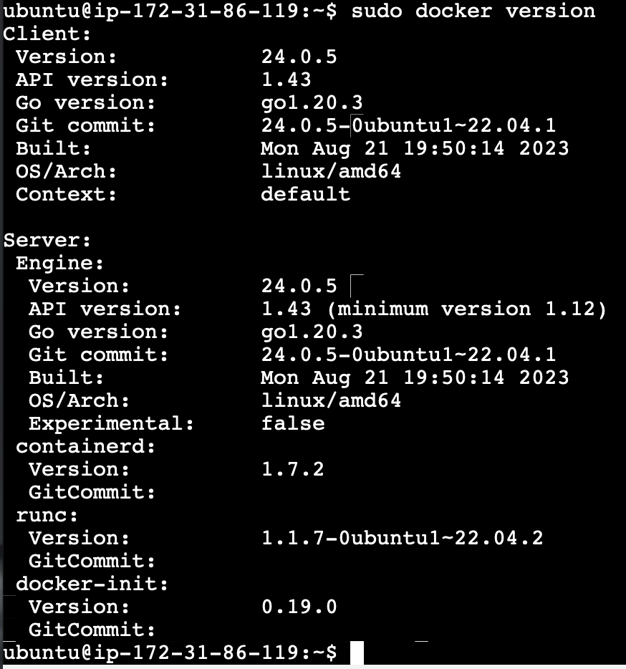

# Adding self-hosted runner in Git hub Repo:

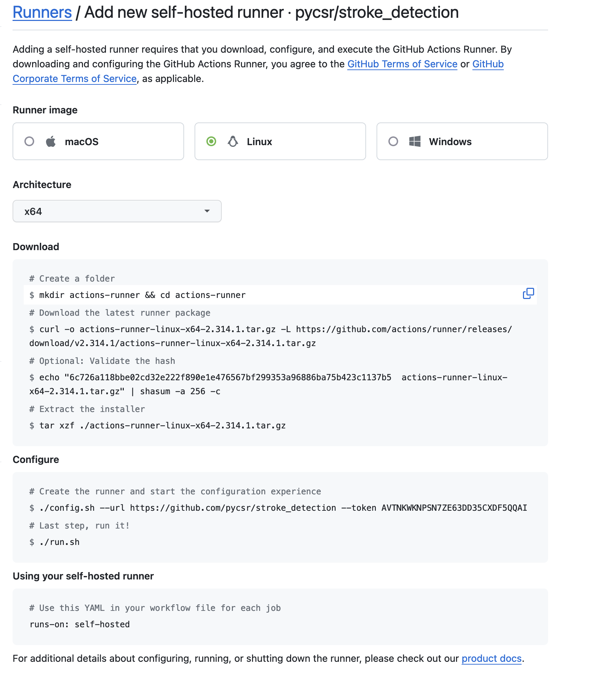

# Running GitHub Actions:

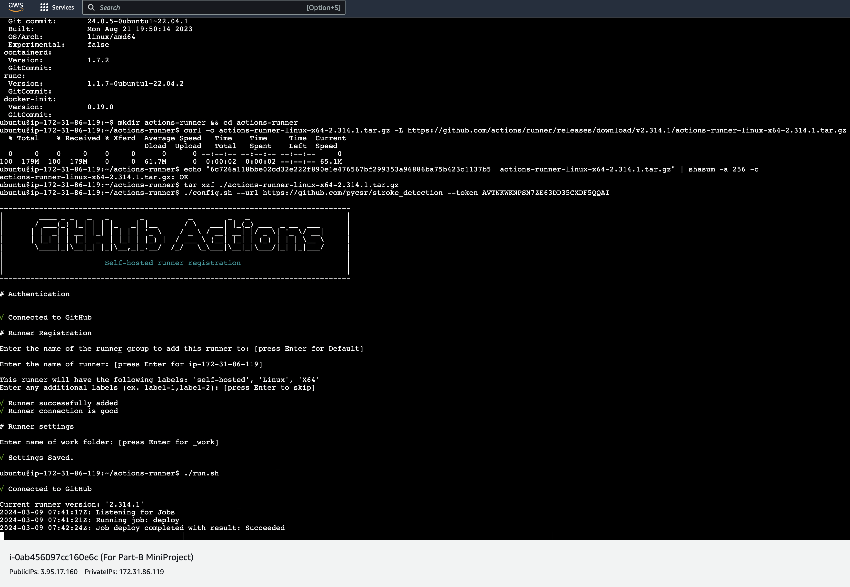

# CD workflow

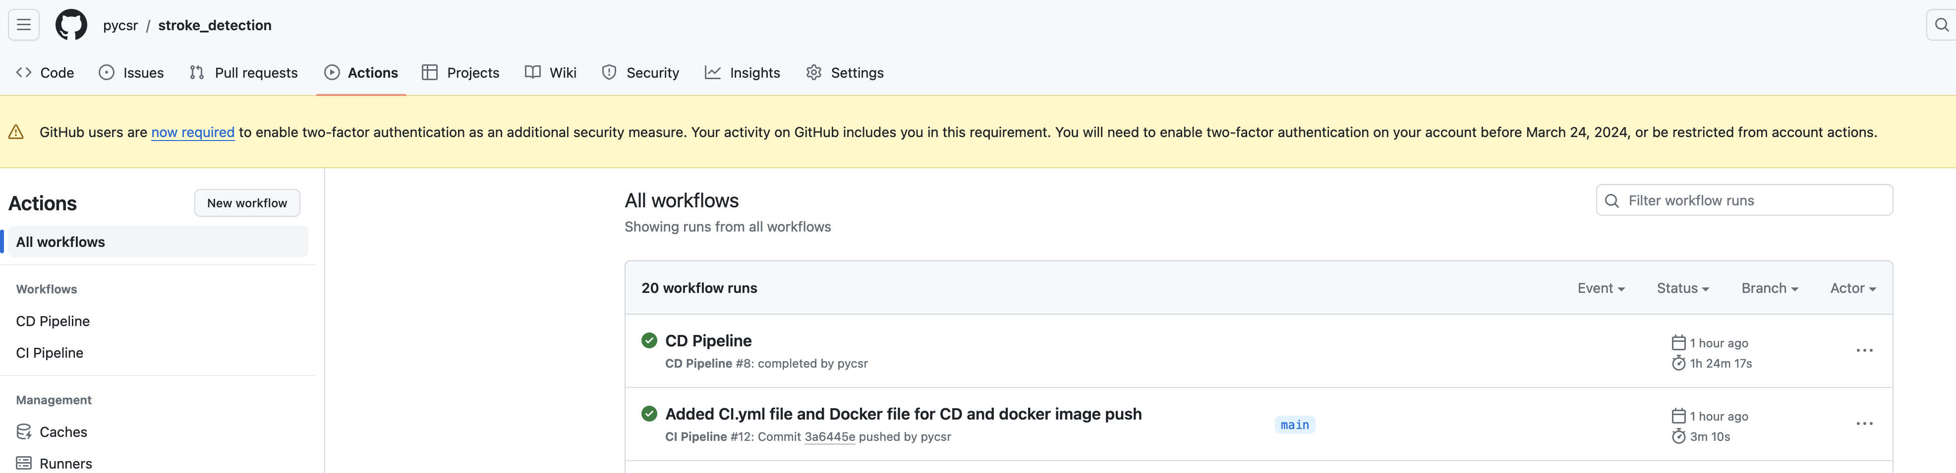

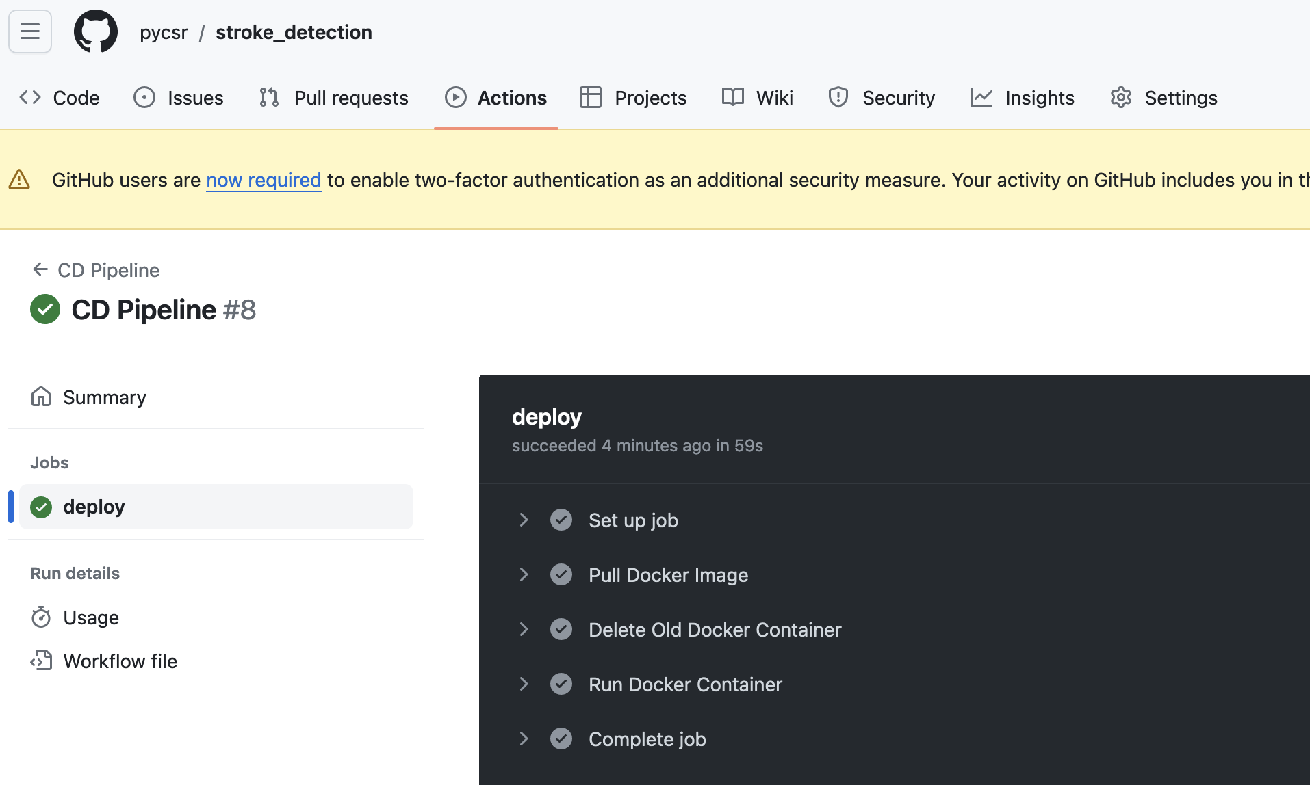

# Running FastApi app on EC2 instance

